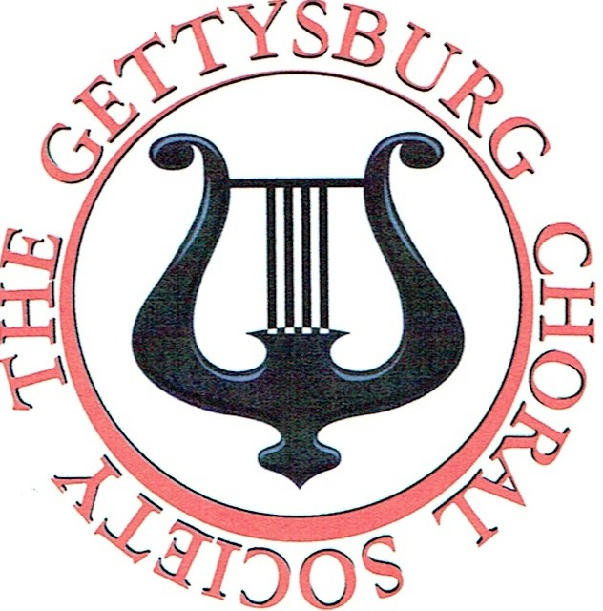
Singers Wanted
The Gettysburg Choral Society of Trinity UCC is currently seeking qualified singers for all voice parts.

Auditions will be held on the following Saturdays:

Saturday, July 28th (Noon - 3:00 P.M.) Saturday, August 11th (3:00 P.M. - 7:00 P.M.) Saturday, September 1st (2:00 P.M. - 6:00 P.M.)

All auditions will be conducted at Trinity United Church of Christ, 60 East High Street, Gettysburg, PA 17325-2319. Persons interested in auditioning should schedule an appointment with our director, John McKay, at (717) 476-1054, or email at zoemckay@aol.com. Additional audition times may be scheduled by special arrangement with the director.
www .facebook.comjgburgchoralsociety

