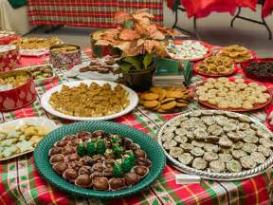
ST. JACOB’S LUTHERAN CHURCH
3444 STICKS ROAD, GLEN ROCK, PA
(Rt. 216, across from Friendship Elementary School) 717-235-7313 email: stjacobs@comcast.net
facebook: StJacobs LutheranChurch
web: www.stjacobslutheran.org

Saturday, December 1, 2018
10 A.M. - Until Sold Out
11TH ANNUAL COOKIE WALK
Homemade Cookies - $15 per Container
(Cookie containers provided)
Gluten & Sugar Free available (Organic natural sweetener)

Advent Market: Other Items:
Advent Wreaths, Ornaments Apple Butter Candy
Books, DVDs, etc. Door Wreaths Cheeseballs
Storytime Church Cookbook
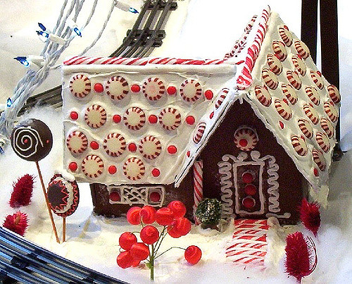

TRAINS with Cookie Decorating
Gingerbread Houses

Food Available: Eat in or take out:
Chicken Corn and Ham & Bean Soup, bowl or quart
Pulled Pork Sandwiches, Pretzel Sandwiches, Hot Dogs

Proceeds benefit World Hunger and church mortgage

