YOU ARE INVITED

HANOVER AREA COUNCIL of CHURCHES
CELEBRATION DINNER
FIFTY YEARS OF SERVICE TO OUR
COMMUNITY
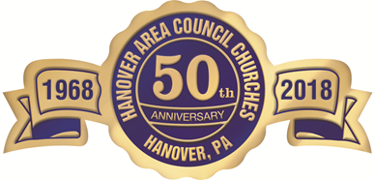
WHEN: DECEMBER 2ND 5 P.M.
WHERE: ST. JOSEPH PARISH HALL
5055 GRANDVIEW RD (REAR PARKING LOT)
COST: $11.95 PERSON / prepaid
Reservations are required:
by check, PayPal or calling the office 717-633-6353

