Coat Collection!!!

coats of friendship

* Collecting used coats, hats, scarves and gloves (any condition)
* Handing out the weekend of Thanksgiving ☺
* Goal is 100 coats!!!!
* Board of Directors run by 9 elementary students/1 middle school student

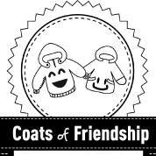

Official 501c3- Federally Recognized Non-Profit!!!

Like us on facebook @ Coats of Friendship – Hanover Chapter!!!!!

717-968-2086 coatsoffriendshiphanover@gmail.com

**ONGOING DROP OFF LOCATIONS!!!!**

* **Markets of Hanover**
* **Representative Kate Klunk’s office**
* **Hickory Falls Family Entertainment**
* **Hanover Area Council of Churches**