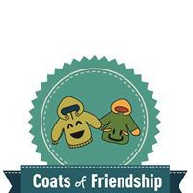
Coats of Friendship, Inc.
Nonprofit Organization-501c3
Founded in 2014
Mission: "Making the World a Little Bit Warmer"

Contact anytime: 717-968-2086

coatsoffriendshiphanover@gmail.com
Facebook page: @CoatsofFriendshiphanover
Website: coatsoffriendship.wixsite.com/website
Board of Directors: 10 elementary students are inspired to collect warm clothing for people in need for York, PA.
Company Overview
Non-Profit aiming to make the world a warmer place through doing things for people in need. Elementary kids are collecting warm clothing for people in need.
General Information
Ongoing coat collection for distribution during the weekend of Thanksgiving for people in need.
Results So Far
We are beginning a new chapter in Hanover, PA area
2018 – Aiming to collect 100 coats
How we would like to partner with businesses in Hanover, PA area?
- Collecting from individual people (used or new coats)
- Collection bins left in businesses
- Handing out flyers in front of business
- Collecting at local fairs, markets and festivals
- Working with local community organizations

