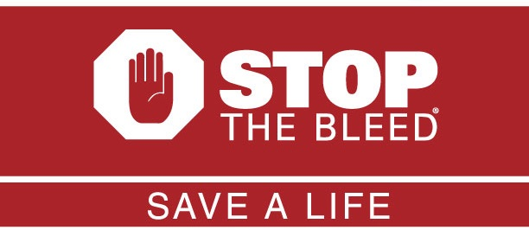
September 7, 2019 – 10:00 a.m.
St. Jacob’s Lutheran Church
3444 Sticks Road, Glen Rock, PA
717-235-7313

We have all watched with horror the many news reports of shootings and terrible accidents in which people have died. Even when police and ambulance crews are on scene in a matter of minutes, people die who otherwise would have lived if bystanders knew how to stop the bleeding from their wounds. Fortunately, we no longer have to stand by and watch as people bleed to death after an attack or accidental injury because we do not have the tools or the knowledge to “stop the bleed.”
“Stop the Bleed” is a program developed by agencies of the federal government utilizing knowledge won on the battlefields of Afghanistan and Iraq in the treatment of injured soldiers and civilians. The materials used in the program can be safely stored on the properties of churches, schools, and businesses, and with a little training can be safely used to save the lives of friends, families, co-workers and neighbors. These kits can be used in your home also.
Ms. Kaitlin Bechtel, Trauma Nurse, Wellspan will conduct the workshop which will include a video training session and a hands on practicum. The training should conclude before noon.
Please let us know the number of participants your organization plans to send before August 25 if possible. Contact us at stjacobs@comcast.net or 717-235-7313.

